LAB ASSIGNMENT: 8
Collage Event Application Structure:
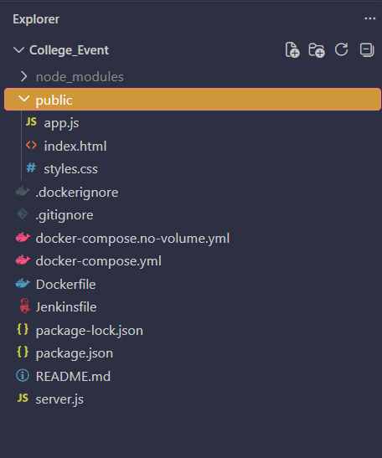
WITHOUT DOCKER VOLUME:
Step 1: docker compose -f docker-compose.no-volume.yml up -d --build
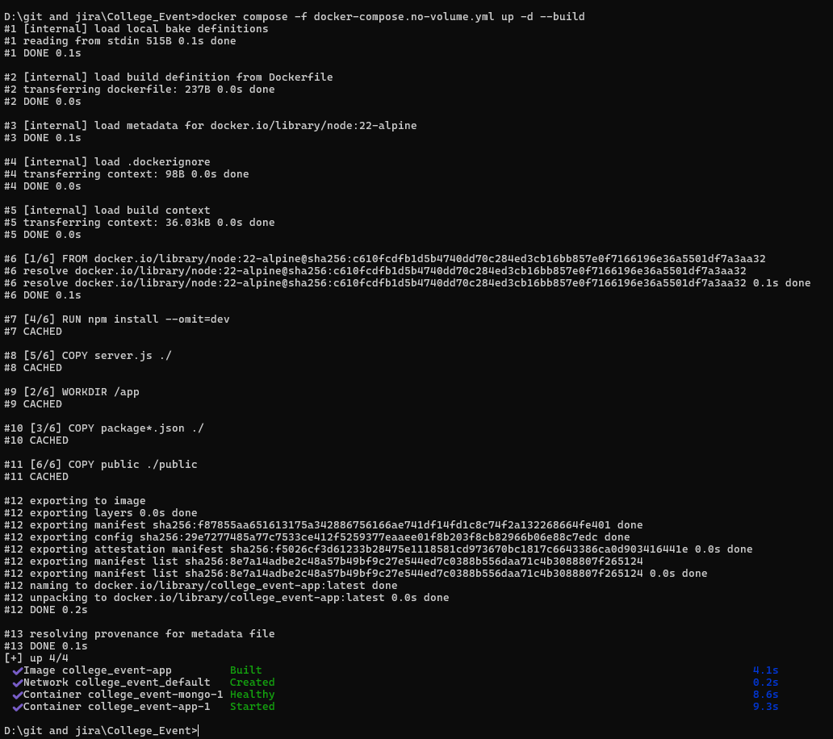
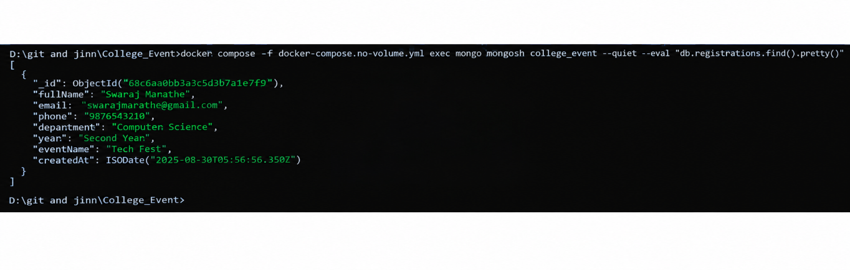
Step 2: docker compose -f docker-compose.no-volume.yml ps
Step 3: Open this address in your browser:
http://localhost:3000
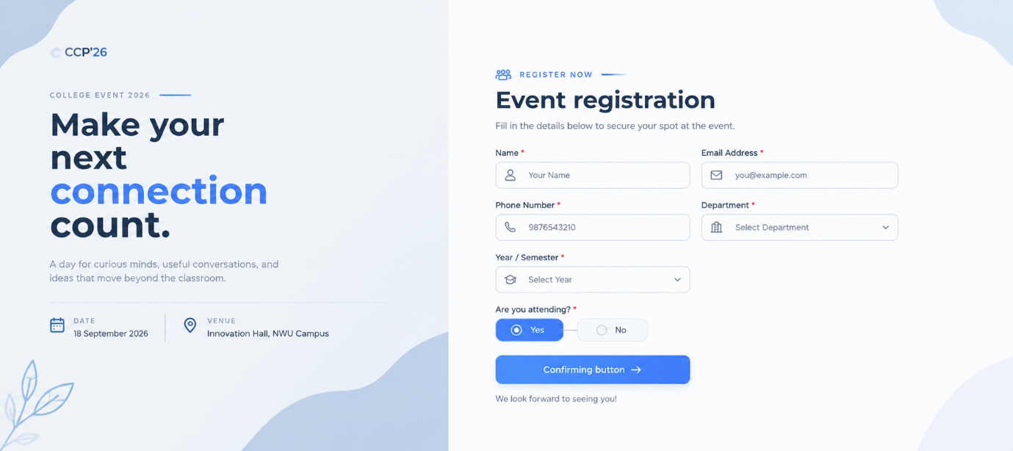
Step 4:
docker compose -f docker-compose.no-volume.yml exec mongo mongosh college_event --quiet --eval "db.registrations.find().pretty()"
Step 5:
docker compose -f docker-compose.no-volume.yml down
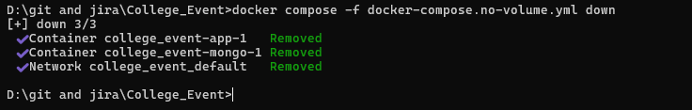

WITH DOCKER VOLUME:
Step 1:
docker compose up -d –build
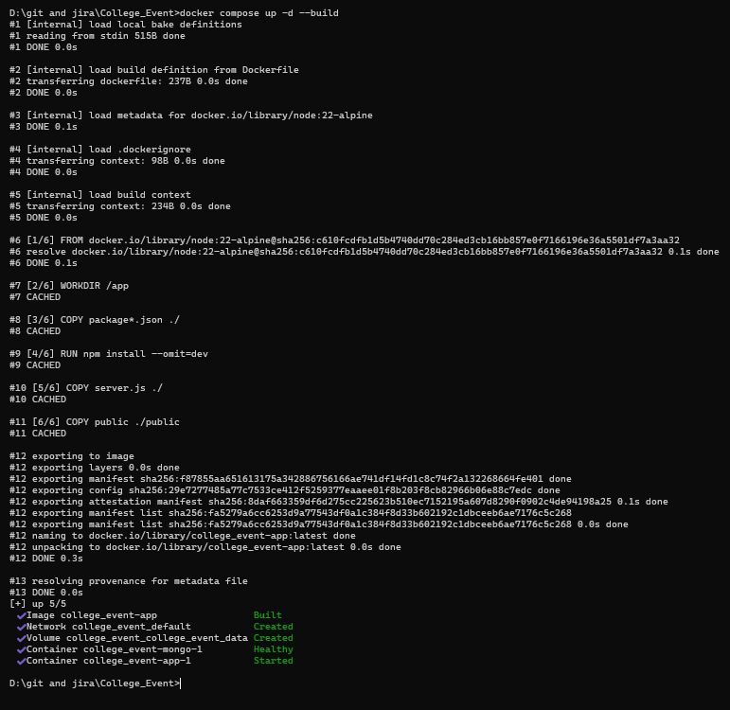
Step 2:
docker compose ps
Step 3: Open this address in your browser:
http://localhost:3000
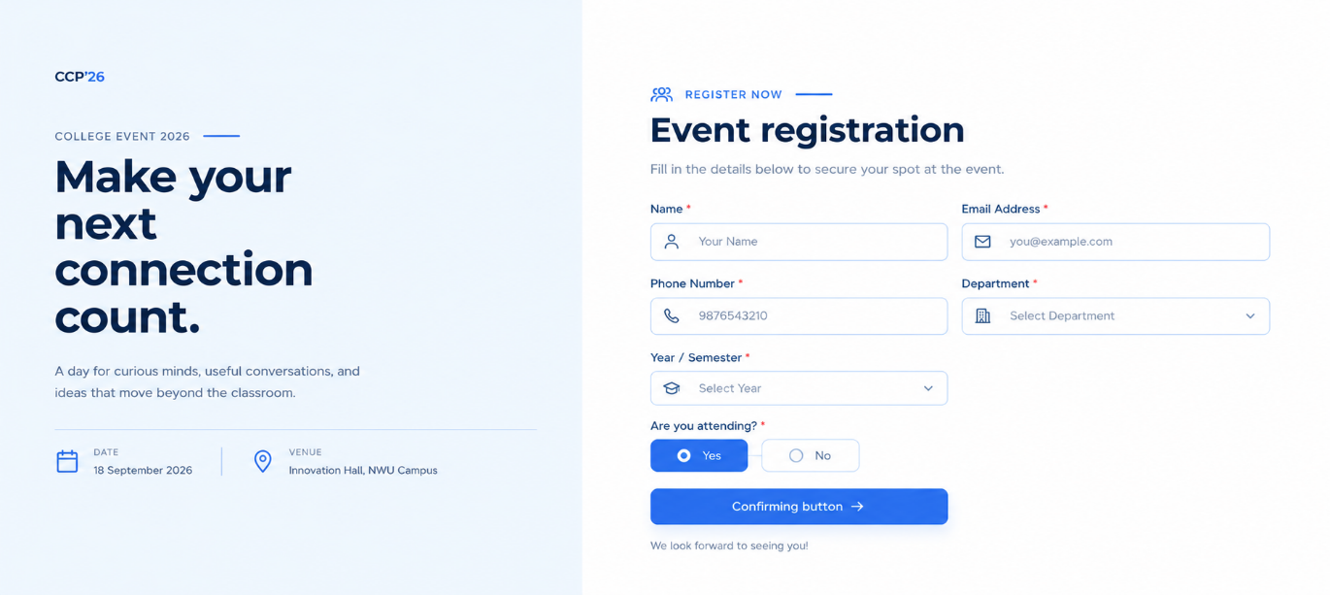
Step 4:
docker compose exec mongo mongosh college_event --quiet --eval "db.registrations.find().pretty()"
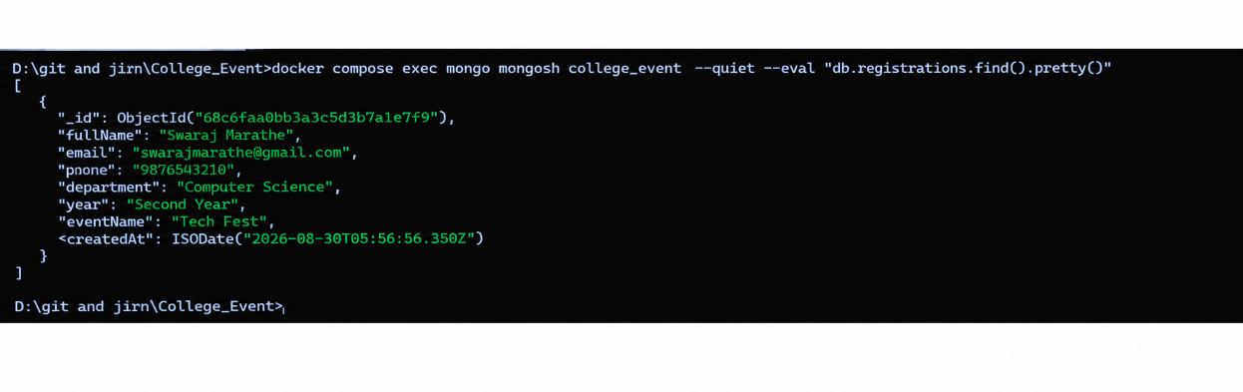
Step 5:
docker compose down
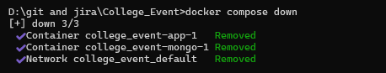
Step 6:
docker compose up –d
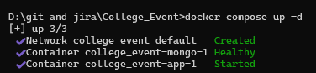
Step 7:
Now without adding the details in the application check if the data is still there
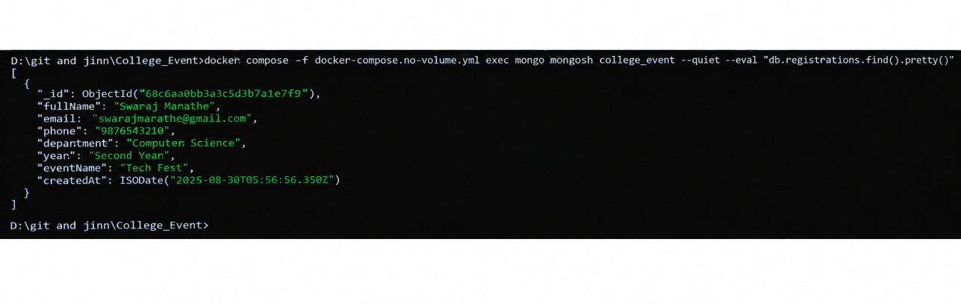
Now Built a Pipeline on Jenkins and Built it:
